**Sales Order Report**

Program: Create an Interactive Report program to display Sales Order Data.

Selection Screen:

Select Options - Order Number, Order Date and Customer ID.

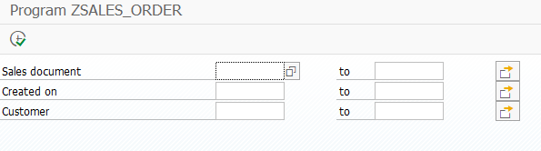

Tables Used:

* KNA1
* VBAK
* VBAP

Description:

1. Accept Customer ID, Order Number and/or Order Date
2. Pass the Data entered in selection screen to the select query.
3. Create a join between KNA1 and VBAK for First Level Output.
4. Display Data of First Level Output.
5. When the user clicks on the Order Number in First Level of Output, display second level of output.
6. If the user, click on the details button in application toolbar, call the Sales Order Display Transaction ‘VA03’.
7. Make a Join between VBAK and VBAP for Second Level Output
8. Display Second Level of Output.

Output:

* Display Basic List – First Level of Output

**First Level output:**

- Order No.

- Order Date

- Customer ID

- Customer Name

- Total order Value

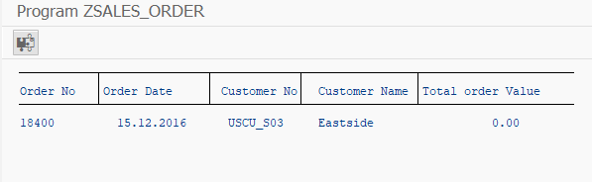

* If button clicked, Call VA03 Transaction and display Sales Order based on index.

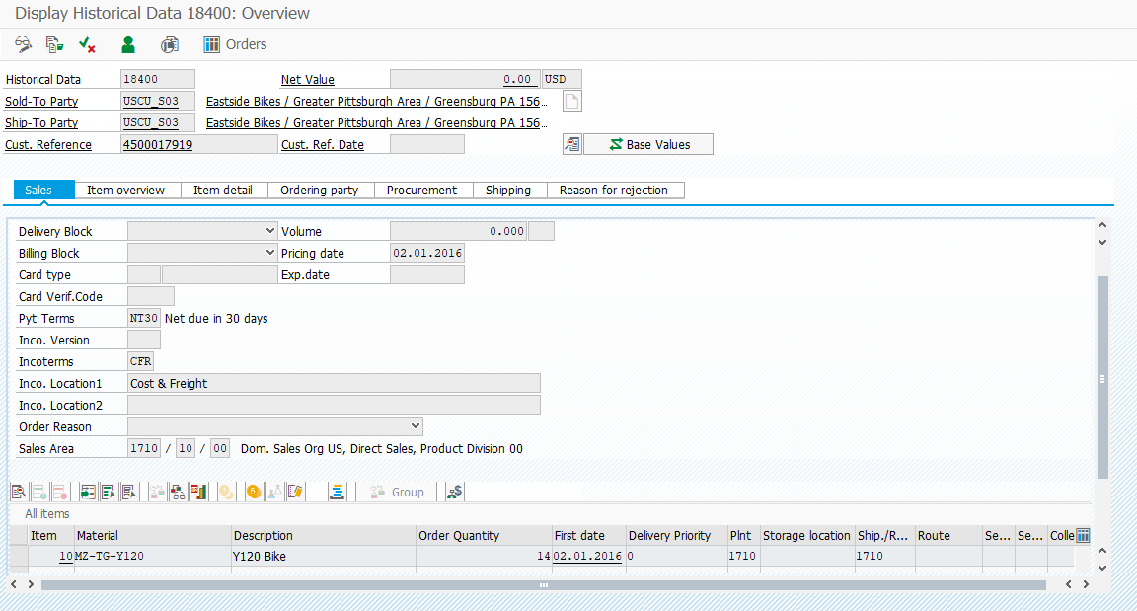

* Display Detail List – Second Level of Output

**On click of Order No**: **Second level:**

* Order No.
* Item No.
* Material Code
* Material Description
* Quantity
* Order Unit
* Item Value

